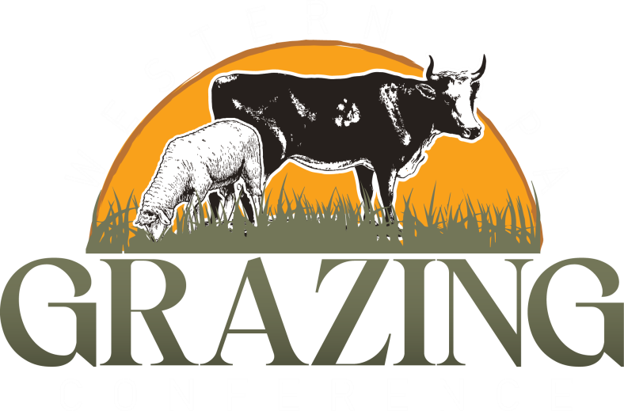
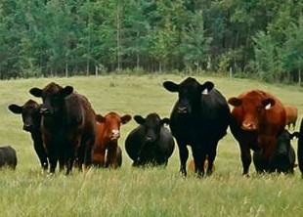
Registration
28th Annual

Thursday, March 12, 2026
Free evening showing of the Roots So Deep Documentary (1&4) on Wed. March 11, 2026

Featuring
Steve Kenyon

At the Trinity Point Church of God
180 W. Trinity Drive Clarion, PA 16214
Presented by the Western PA Grazing Conference Committee
Note: Choose breakout sessions you wish to attend
(select letter from agenda) for the morning & afternoon
(ex. A/C) beside your name.
Name(s) am/pm
/
/
/ Address City State Zip Email Phone
Registration Fees Deadline March 5, 2026
Evening 3/11/26 # FREE
Day 3/12/26 # x $45.00 =
Total Amt. Enclosed $

Mail registration & check payable to:
Clarion Conservation District
249 S. Second Avenue Clarion PA 16214
Or Register Online

www.westernpagrazing.com
Questions? Contact: Clarion CD at 814-393-6147 or Jefferson CD at 814-849-7463
Clarion Conservation District
249 S. Second Avenue
Clarion PA 16214
Registration fee for 3/12 includes a
continental breakfast & hot buffet lunch

 Wednesday Evening 03/11/26
6:30pm - 9:00pm
Roots So Deep Documentary
Roots So Deep (You Can See the Devil Down There) is a 4-part documentary series that explores the world of adaptive cattle farmers and their conventional farming neighbors. Join us for a free viewing of episodes 1 & 4.
Note: The documentary will start promptly at 6:30, so please arrive ~15min. early to grab a snack/drink and choose your preferred seat.

Nearby Hotels
Hampton Inn 814-226-4444
4 Hospital Dr., Clarion PA 16214
Microtel Inn & Suites 814-227-2223
121 North Point Dr. Clarion PA 16214
Holiday Inn Express 814-223-4010
325 Perkins Rd. Clarion, PA 16214

Be sure to visit our many vendors & sponsors showcasing their products & services at the conference!!

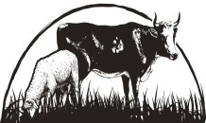
Western PA Grazing Conference
Committee Members
USDA-Natural Resources Conservation Service
Jefferson, Clarion, Clearfield Conservation Districts NW & SW PA Project Grass
Penn State Extension Local Farmers
Grant support from PA Grazing Lands Coalition

Thursday 03/12/26
7:30 - 8:30 Registration
8:30 - 9:00 Welcome, Sponsors
9:00 - 10:30 Growing Soil - Steve Kenyon, Greener Pastures Ranching Ltd.
10:30 - 11:15 Vendors/Sponsors
11:15 - 12:00 Breakout Sessions
- Forages for Beef Cattle - Dr. Guojie Wang, Penn State University
- Building Soils and Barns: Developing and Furthering a 100% Grass Fed Dairy - Nathan Weaver, NY Dairy Farmer
- A New Herd, A New Vision: How We Transformed a Dairy Mindset into a Grazing-Based Beef Profitability - Amanda & Mike Butterfield, Maple Valley Cattle Co.
12:00 - 1:00 Lunch
1:00 - 2:30 What Bugs Me -Steve Kenyon, Greener Pastures Ranching Ltd.
2:30 - 3:00 Visit Vendors/Sponsors
3:00 - 4:00 Breakout Sessions
- Managing Katahdin Sheep to Reduce Risk of Parasites Tom Perkins, Big Tom’s Con-O- Creek Farm
- Complementary Incomes: Ideas for Income
Streams Aside from Milk Sales -Nathan Weaver, NY Dairy Farmer
- Farm Planning Succession - Samantha Gehrett & Paula Ledney, Penn State Ext., Chris Leiden, Leiden Land & Cattle Co, Inc.
- Drone Capabilities - Garrett Schick, GS Custom Ag Services LLC.
4:00 - 4:45 Speaker Panel
4:45 - 5:00 Closing, Door Prizes, Evaluations

Meet Our Keynote Speaker

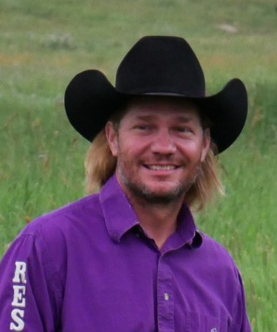
Steve Kenyon
For over 25 years, Steve Kenyon has been custom
grazing on leased land near Edmonton, Alberta under
the name of Greener Pastures Ranching Ltd.
By using extended grazing techniques, he is able to pasture cattle year-round. This is done by using a combination of regenerative and dormant season grazing as well as swath grazing, crop
residue and bale grazing.
Steve has been teaching sustainable grazing
management along with agricultural economics for more than 20 years. He has been a keynote speaker at many conferences and seminars
throughout Canada, the U.S. and Europe. He has also been a writer for the Stockman Grass Farmer for over 15 years, as well as the creator and host of the ongoing Wednesday Night Networking
webinar and podcast. Steve has become well
respected in the agriculture community for his business management practices and innovative ideas.

Greener Pastures Ranching is a regenerative farm with environmental goals focused on creating a
living soil, healing the water cycle and rebuilding ecosystems. Our mission statement is “Economic and Environmental Sustainability for
Generations.” It is important to us to provide an enjoyable, profitable and sustainable business for future generations.

