Barnett Township – Songer Road Project

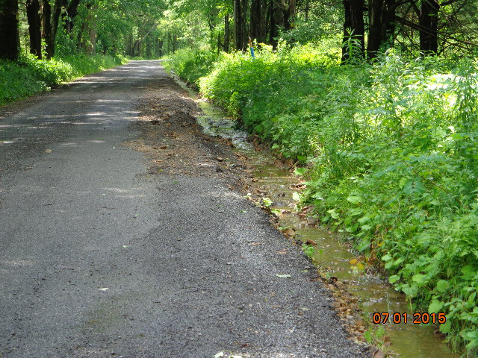

Before

**Problem**: Water from several sections of Songer Road was being directed onto Shaffer Road, where it was washing out the ditches and eroding the existing driving surface.

**Solution**: A new cross pipe, headwall and tailwall, were installed across Songer Road to divert water away from Shaffer Road and into a grassy area.

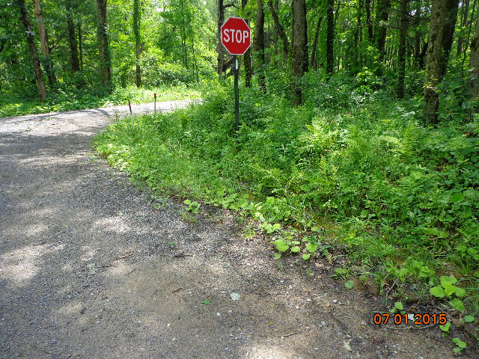  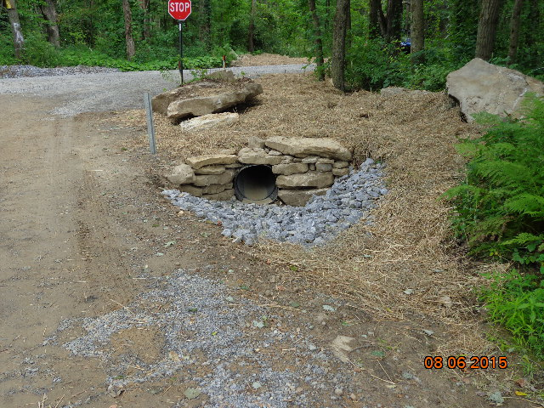

After

Before