Barnett Township – Shaffer Road Project

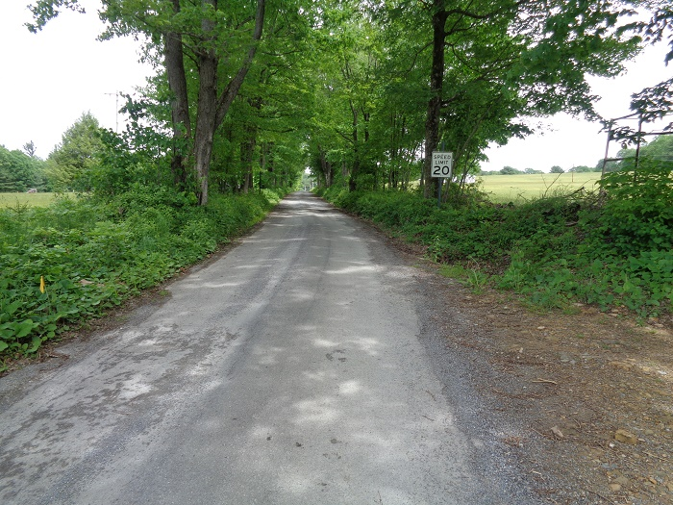  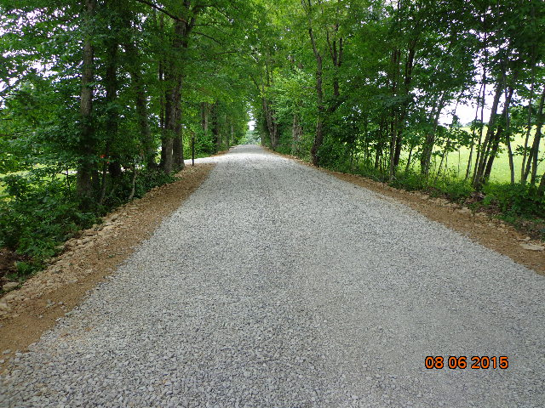

After

Before

**Problem**: The Township Road was entrenched, acting as a funnel for a large nearby field. The concentrated runoff repeatedly washed out the ditches, directing sediment to the nearby stream.

**Solution**: The road profile was filled with 3 feet of shale, which brought the road grade slightly above the surrounding area. The road was shaped to incorporate a crown so that any stormwater would sheet flow off of the road into the grassy areas on each side of the road.